**DAILY ONLINE ACTIVITIES SUMMARY**

|  |  |  |  |  |  |  |  |  |
| --- | --- | --- | --- | --- | --- | --- | --- | --- |
| **Date:** | **29/05/2020** | | | | | **Name:** | **Manish B Shriyan** | |
| **Sem & Sec** | **8th sem B sec** | | | | | **USN:** | **4AL16CS131** | |
| **Online Test Summary** | | | | | | | | |
| **Subject** | | **BDA** | | | | | | |
| **Max. Marks** | | **30** | | **Score** | | | **22** | |
| **Certification Course Summary** | | | | | | | | |
| **Course** | **Amazon DynamoDB for Serverless Architectures** | | | | | | | |
| **Certificate Provider** | | | **AWS** | | **Duration** | | | **2 Hour** |
| **Coding Challenges** | | | | | | | | |
| **Problem Statement:**  **Write a C Program to generate first N Armstrong Numbers.** | | | | | | | | |
| **Status: Solved** | | | | | | | | |
| **Uploaded the report in Github** | | | | | **Uploaded** | | | |
| **If yes Repository name** | | | | | **ManishShriyan** | | | |
| **Uploaded the report in slack** | | | | | **Yes** | | | |

Online Test Details:

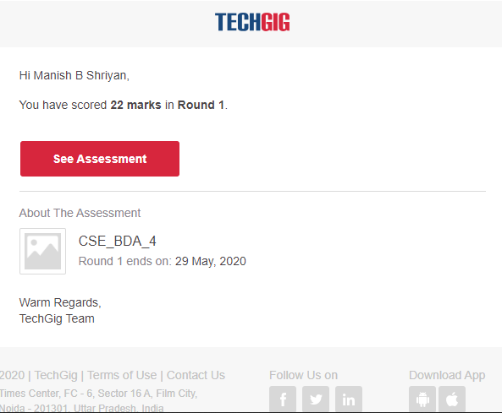

Certification Course Details:

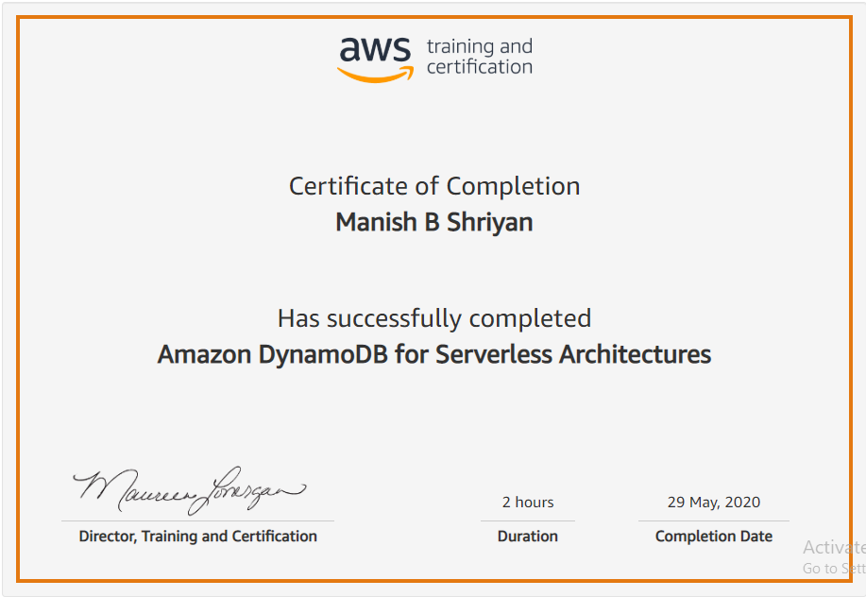

Coding Challenges Details:

#include<stdio.h>

void main()

{

    int n,copy=152,remainder,sum,x;

    printf("Enter a number\n");

    scanf("%d",&n);

    //starting copy from 152 as we know 153 is an armstron no

    printf("Armstrong numbers are\n");

    while(n!=0)

    {

        copy++;

        x=copy;

        sum=0;

        //printf("\n2nd copy = %d ",copy);

        while(copy!=0)

        {

            remainder=copy%10;

            sum=sum+remainder*remainder*remainder;

            copy=copy/10;

        }

        if(sum==x)

        {

            printf("\n%d",x);

            n--;

        }

        copy=x;

    }

}